Personal tasks in the first week:

Basic flow

Student Name: Hu mingzhi
Student No: 201532120120
Team Name: Ming
GitHub Repository: https://github.com/OOPClassTeamMing/OOPClassRepository.git
Date: 2017/11/24
GitHub Username: Hmz3192

Overview: The way our group works is that each person is responsible for a part, and then when we finish, the sum is a whole part, the following is my personal division of labor.

3. Basic flow
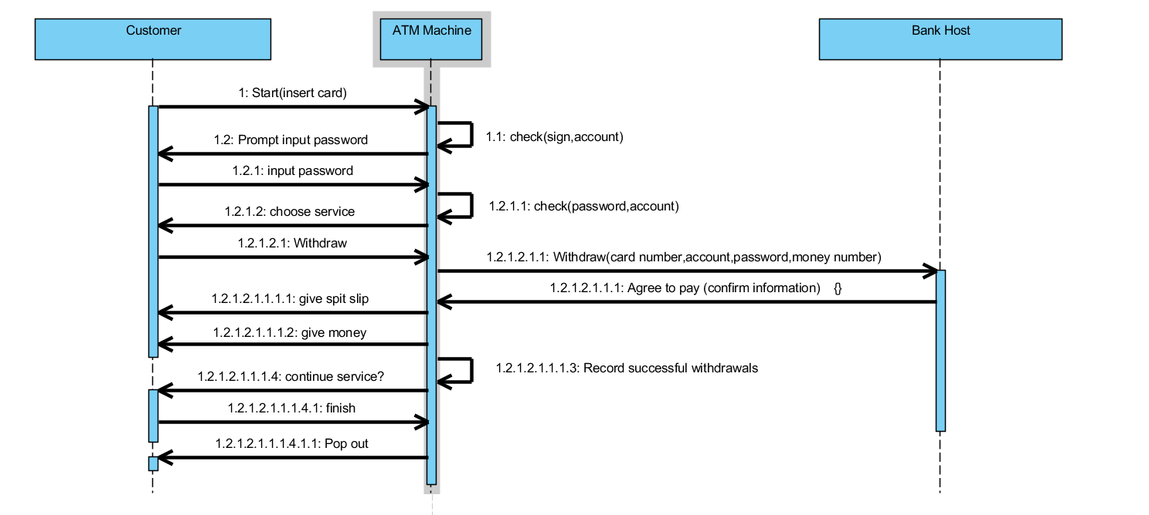

Reference material：
Qiu Yuhui USE CASE introduction and examples Tsinghua University press

